

BLOOMINGTON SOUTH FOOTBALL
MEDIA GUIDE

Dear Business Owners and Community Members,
Official practice starts soon and we have over 100 Panther student athletes eager to start working towards fall! We are grateful to all past sponsors and appreciate your continued support. At the same time, we warmly welcome new sponsors to join the team helping players reach their full potential and assisting the Panthers in staying a first-class program. There are multiple ways to advertise your business while supporting Panther Football!
The Media Guide is 40+ pages and over 1000 copies… making it a great advertising value. Guides are handed out FREE at Varsity home games and JV/freshman home games. A 6’ x 3’ full-color vinyl banner is also available. These are displayed inside the stadium all season. They are very visible to the masses!
Funds raised go towards expenses such as, but not limited to: field equipment, upkeep, uniforms, media and video equipment, team meals, coaches professional dues, and education. A portion of the funds go toward the general athletic fund to benefit all BHSS athletes.
Thank you for your consideration in supporting Panther Football! Please contact us if you have questions.
Sincerely,
BHSS Quarterback Club
Media Guide Committee

Melissa Quick Heidi Smith
melissa@helpingbulls.com craigandheidi@bluemarble.net
317-381-1967 812-320-9472

Advertising Opportunities
 GAME BALL SPONSORSHIP - $1400
- 6’ x 3’ Color Vinyl Banner displayed on fence during regular season
- 3.5” x 2” Color Business Card ad in media guide
- Autographed football by Seniors (delivered to you game week)
- PA announcement for your business made 4-5 times during sponsored game
- Company merchandise handed out to fans (examples: koozies, tshirts, rally towels)
 FENCE BANNER SPONSORSHIP - $650
- 6’ x 3’ color vinyl banner displayed on fence during regular season
EXCLUSIVE BACK COVER AD - $1300
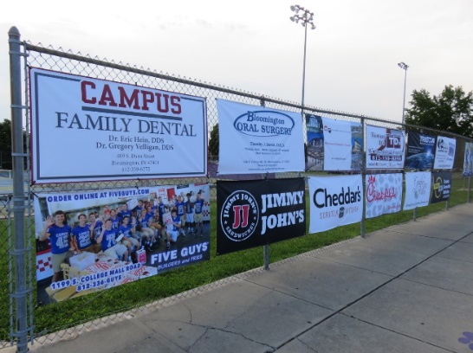
- 8.5” x 11” full-color, heavy paper
EXCLUSIVE INSIDE FRONT/BACK COVER AD - $1200
- 8.5” x 11” full-color, heavy paper
FULL PAGE AD - $1100
- 7.5” x 10”
HALF PAGE AD - $550
- 7.5” x 4.75”
QUARTER PAGE AD - $475
- 3.5” x 4.75”
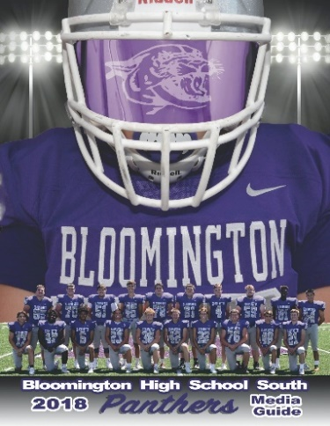
 BUSINESS CARD AD - $325
- 3.5” x 2”
BOOSTER DONATIONS – business or family name listed on Booster page
- Championship Level - $500 and above
- Touchdown Level - $200-$499
- Goal Line Level - $100-$199

Artwork Specifications
We send ad in PDF format. For fence banners, we need a strong file since the banners are very large. Please submit artwork and payment ASAP. DEADLINE is JUNE 1, 2023.

MEDIA GUIDE ADVERTISING CONTRACT
BUSINESS NAME: ___________________________ CONTACT NAME: ___________________________
PHONE NUMBER: ____________________ EMAIL ADDRESS: ___________________________________
ADDRESS: ____________________________________________________________________________
CITY: ___________________________________________ STATE: _____ ZIP: _____________________
Please send contract, artwork, and payment ASAP. DEADLINE is JUNE 1, 2023.
ITEM | DESCRIPTION | PRICE | QUANTITY | TOTAL
Sponsorship | Game Ball Sponsor | $1400
Banner | Fence Banner | $650
Media Guide Ad | Back Cover | $1300 | reserved
Media Guide Ad | Inside Back Cover | $1200 | reserved
Media Guide Ad | Inside Front Cover | $1200 | reserved
Media Guide Ad | Full Page | $1100
Media Guide Ad | Half Page | $550
Media Guide Ad | Quarter Page | $475
Media Guide Ad | Business Card Size | $325
Booster | Championship | $500+
Booster | Touchdown | $200-$499
Booster | Goal Line | $100-$199
TOTAL $

Artwork
Please email your ad in PDF format. We keep previous ads on file if you would like to use them.
Payment
Please mail to the address below OR pay online using our DONATE button at bhsspantherfootball.com. Please note your business when paying online.

Signature__________________________________________ Date_________________________

PLEASE MAKE CHECKS PAYABLE TO “BHSS QBC”
MAIL: Heidi Smith 3684 E Sterling Ave Bloomington, IN 47401
QUESTIONS? craigandheidi@bluemarble.net 812.320.9472

